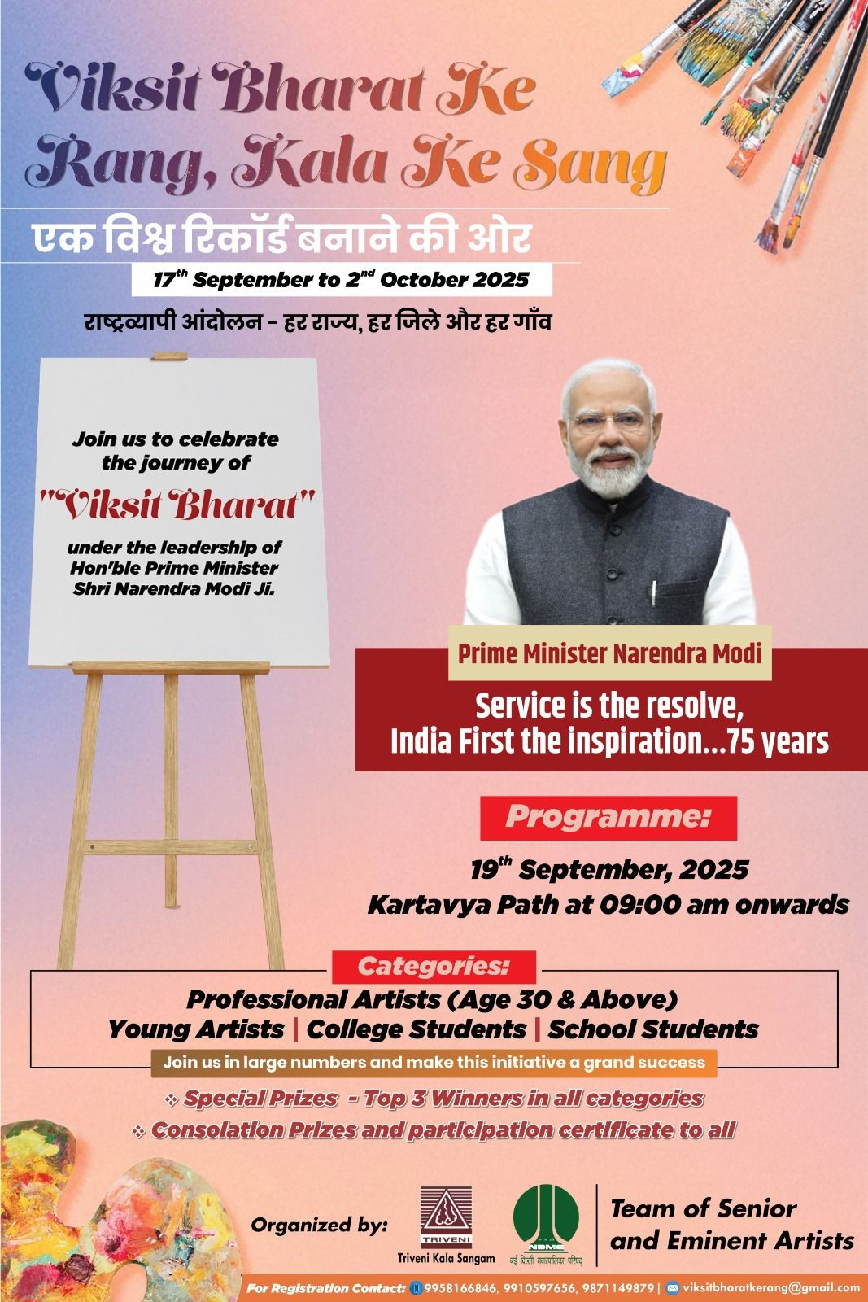

Prime Minister Narendra Modi
Service is the resolve,
India First the inspiration...75 years

“Viksit Bharat Ke Rang, Kala Ke Sang”

एक विश्व रिकार्ड बनाने की ओर
17th September to 2nd October, 2025

Join us at the Kartavya Path on Friday, the 19th September 2025 , 9:00 AM onwards (Unleash your artistic side)
राष्ट्रव्यापी आंदोलन - हर राज्य, हर जिले और हर गाँव

NDMC and University of Delhi, in collaboration with Triveni Kala Sangam, proudly presents “Viksit Bharat Ke Rang, Kala Ke Sang” — a grand artistic tribute to the spirit of India: its vibrant culture, timeless heritage, and unstoppable journey towards a Viksit Bharat @2047.

This special celebration honors the visionary leadership of Hon’ble Prime Minister Shri Narendra Modi Ji on the historic occasion of his 75th Birthday.

Pre-registration is mandatory as per Google Link :- https://forms.gle/y3quHeHjX4uppk6fA

📞 Contact: 9958166846, 9910597656, 9871149879 I Email ID - viksitbharatkerang@gmail.com

